5TH Year Of Helping The Animal Rescue Community  Rescues And Shelters  with animals  From (3) Counties  Animal Friendly Exhibitors | 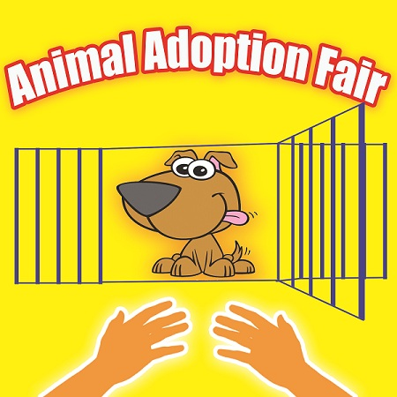 | Lots Of Media Coverage  Sponsor And Ad Spaces Avilable  Free Spaces For ALL 501c3 Rescue/Shelters That Sign Up!!!  (Before August 1st)
Animal-Friendly  Bring your well-behaved  animals on leash  or in pet carriages  Food, Music &  Entertainment | 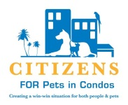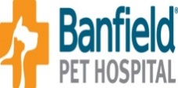 | Veterinary Care  Vaccinations  Micro-chipping  Hospice  Ear Cleaning  Nail Clipping  Teeth cleanings
*** Come Join Us for A Day Of Fun And Entertainment ***
Sunday, August 23rd, from 10-6pm
Live Music War Memorial Auditorium Animals to Adopt
Free Admission (800 NE 8th St. Ft. Lauderdale, FL) Free Parking
Silent Auction All Indoors and Air Conditioned! Silent Auction
Food & Drinks Vendor spaces $200, $250 corner Giant Raffle
Wanted - vendors / animal related services! Go to: www. animaladoptionfair.com
For more info call Brook @ 954-971-4432 or scan

